**BALKRISHNA BUDHATHOKI**

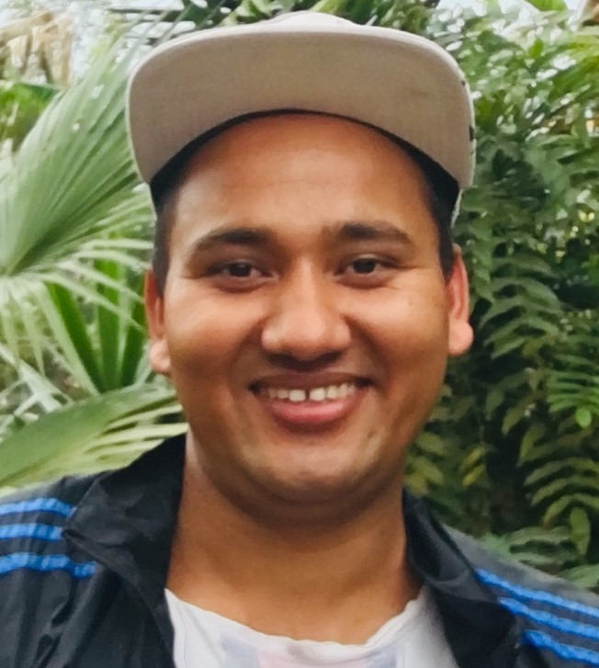

PROFILE

Senior Web Developer specializing in front end development. Experienced with all stages of the development cycle for dynamic web projects. Well-versed in numerous programming languages including HTML5, PHP OOP, JavaScript, CSS, MySQL. Strong background in project management and customer relations.

Skill Highlights

|  |  |
| --- | --- |
| * Project management * Strong decision maker * Complex problem solver | * Creative design * Innovative * Service-focused |

Experience

**Web Developer** - 09/2015 to 05/2019

**Luna Web Design**, New York

* Cooperate with designers to create clean interfaces and simple, intuitive interactions and experiences.
* Develop project concepts and maintain optimal workflow.
* Work with senior developer to manage large, complex design projects for corporate clients.
* Complete detailed programming and development tasks for front end public and internal websites as well as challenging back-end server code.
* Carry out quality assurance tests to discover errors and optimize usability.

Education

Bachelor of Science: **Computer Information Systems** - 2014

**Columbia University**, NY

Languages

Spanish – C2

Chinese – A1

Certifications

PHP Framework (certificate): **Zend, Codeigniter, Symfony**.

Programming Languages: **JavaScript, HTML5, PHP OOP, CSS, SQL, MySQL**.

+977 9843895577

[christoper.m@gmail.com](mailto:christoper.m@gmail.com)

Chitwan, Ra na pa-4